Data Model: Music/Content Streaming Platform

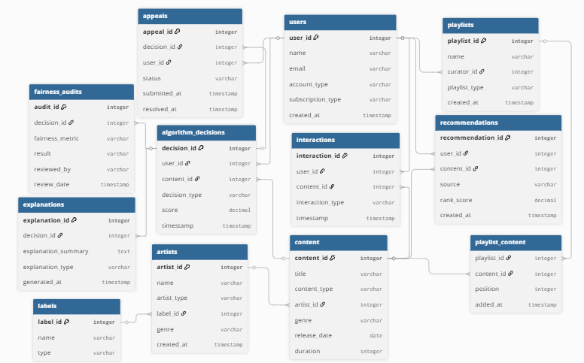

Key Design Decisions
The data model was designed to separate core system functionality from transparency and fairness features to better support the goals of the transparency portal. One key decision was to introduce an Algorithm Decision entity that exists independently from recommendations. This allows the system to track not just what content is shown to users, but also how and why those decisions are made. Additionally, an Explanation entity was created to support user facing transparency by storing different levels of explanations without exposing proprietary algorithm details. A Fairness_Audit entity was also included to enable the organization to evaluate and monitor potential bias, particularly regarding concerns such as major label versus independent artist visibility. The inclusion of Interaction data supports the ability to analyze how engagement driven algorithms influence outcomes. Finally, an Appeal entity was added to represent human in the loop processes, allowing users to challenge automated decisions and improving accountability.

Assumptions & Uncertainty
Several assumptions were made due to gaps in the case information. It is assumed that the platform collects and stores detailed user interaction data, such as plays, skips, and likes, which can be used to inform algorithmic decisions. It is also assumed that explanations can be generated in a way that provides meaningful insight to users without revealing sensitive or proprietary algorithmic logic. Another assumption is that fairness metrics, such as exposure balance or diversity scores, will be defined and measurable, even though the case does not specify how fairness should be evaluated. Additionally, it is assumed that a single algorithmic decision may have multiple associated explanations and fairness audits over time. There is also uncertainty around the level of data that can be stored or exposed due to legal and compliance constraints, which may impact how detailed explanations and audit records can be.

How This Connects to the Case
This data model directly supports the goals of the Algorithmic Fairness and Transparency Portal by aligning with the key challenges identified in the case. The inclusion of the Explanation entity enables the system to provide users with clear, accessible information about how decisions affect their experience, addressing transparency concerns. The Fairness_Audit entity supports the evaluation of algorithmic outcomes, helping the organization monitor and address bias, such as disparities between major label versus independent artist visibility. The model also reflects stakeholder needs by balancing transparency with risk: compliance concerns are addressed through controlled explanation storage, while user trust is supported through explanations and appeal mechanisms. Furthermore, the model aligns with previously proposed transparency tiers by separating public facing explanations, user specific details, and internal audit data. Overall, this design ensures that the system can support both organizational accountability and user trust while remaining adaptable to evolving requirements and constraints.

